**TEST**

**PRODUCT**

**QUALIFICATION**

**REPORT**

**TITLE:**

LT8609S Test Site Transfer from Analog Devices Singapore to

Analog Devices General Trias Philippines

**PCN Number:**

PCN 20_0231

**REVISION:**

A

**DATE:**

September 2020

**CONTENTS:**

**Summary**

**Table 1** – LT8609S Test Details

**Table 2** – Product Correlation Representative Identification

**Table 3 –** Qualification Activities and Acceptance Criteria

**Table 4** – Correlation Device Run Results

**Table 5** – Product Site Transfer Correlation

**Table 6 –** Manufacturing Validation Lot Run

**Table 7 –** GR&R Result

**PROJECT BACKGROUND:**

The LT8609S is currently undergoing production testing at the Analog Devices Singapore (ADSG). It was a strategic decision from business standpoint to qualify Analog Devices General Trias (ADGT) which will soon serve as production site after ADSG closure. ADGT is situated in Gateway Business Park, General Trias, Cavite, Philippines. The manufacturing facility have 1 Million square foot building in a 15 hectares land area. It houses ~900 Testers and ~1000 handlers with 4,850 total employees which includes 1,000 engineers composed of Test, Product, Failure Analysis, Reliability, Design and Layout Engineers. ADGT passed and qualified on different certifications such as: IATF 16949, ISO 9001, ISO 14001, OHSAS 18001, ANSI ESD S20.20, IEC 61340-5-1. The plant produces 375 Million test output per quarter and caters different testing capability such as Package Testing, WLCSP Testing and Die Preparation, Wafer Trim and Probe and Mil-Aerospace Assembly & Test. In terms of product test capability, ADGT caters testing for Automotive, RF, Power, MEMS, µIsolators, Mixed Signal High Speed Precision Converters and Mil-Aerospace products. After qualification and replication of necessary test capability, ADGT will serve as the primary test site facility to serve future demands.

**SUMMARY:**

The LT8609S is a compact, high efficiency, high speed synchronous monolithic step-down switching regulator that consumes only 1.7µA of non-switching quiescent current. The LT8609S can deliver 2A of continuous current with peak loads of 3A (<1sec) to support applications such as GSM transceivers which require high transient loads. Top and bottom power switches are included with all necessary circuitry to minimize the need for external components. Low ripple Burst Mode operation enables high efficiency down to very low output currents while keeping the output ripple below 10mVP-P. A SYNC pin allows synchronization to an external clock or spread spectrum modulation of switching frequencies for low EMI operation. Internal compensation with peak current mode topology allows the use of small inductors and results in fast transient response and good loop stability. The EN/UV pin has an accurate 1V threshold and can be used to program VIN undervoltage lockout or to shut down the LT8609S reducing the input supply current to 1µA. A capacitor on the TR/SS pin programs the output voltage ramp rate during start-up while the PG flag signals when VOUT is within ±8.5% of the programmed output voltage as well as fault conditions.

**TEST AND PRODUCT INFORMATION:**

Device: LT8609S

Package: 16-LEAD LQFN

Leads: 16 LEADS

FG Partname: LT8609SIV#WPBF

Tester Platform: ETS364B

Handler: MT9510

The LT8609S is planned to be tested in Analog Devices General Trias (ADGT) using the following as shown in the Table 1 below:

***Table 1****: LT8609S Test Details*

|  |  |  |  |
| --- | --- | --- | --- |
| **Parameters** | **ADSG** | **ADGT** | **Remarks** |
| Tester Platform | ETS364B | ETS364B | No change |
| Handler | MULMT9510 | MULMT9510 | No Change |
| Test Flow | FT_Room 100%-QAR-QAC-QAH | FT_Room 100%-QAR-QAC-QAH | No Change |
| Contactor | GMK050-0016KJ22 | L-59650 | No change  (Apply ADI Hardware naming standard) |
| Performance Board | LT8609S | L-65028 | No change  (Apply ADI Hardware naming standard) |
| Test Program | LT8609SIV | V17910P90 | No change  (Apply ADI Program Filename Standard) |

There is no change to the form, fit and function of the product.

This report documents the successful completion of the product test transfer requirements of LT8609S at ADGT.

**DESCRIPTION AND TEST RESULTS:**

To qualify LT8609SIV#WPBF, LT8609AIMSE#3LCPBF a 42V, 3A Synchronous Step-Down Regulator with 2.5µA Quiescent Current was identified as product correlation representative based on the following criteria: same product technology, same function and operation, and same tester platform. Being Switching Regulators, both LT8609SIV and LT8609AIMSE have the same typical application as Synchronous Step-Down Regulator. Additionally, both LT8609SIV and LT8609AIMSE have the same input voltage range, same range of adjustable and synchronizable frequency and same high efficiency at 2MHz Synchronous Operation. Both have the same test coverage on critical datasheet parameters: Minimum Input Voltage, Vin Quiescent Current, Vin Current in Regulation, Feedback Reference Voltage, Feedback Voltage Line Regulation, Feedback Pin Input Current, Minimum On/Off time, Oscillator Frequency, Top Power NMOS Current Limit, PG Upper/Lower Threshold Offset, PG Leakage, Sync Input High/Low Voltage and TR/SS Source Current. Comparison were analyzed and summarized at Table 2.

**Table 2:** *Product Correlation Representative Identification*

|  |  |  |  |  |  |
| --- | --- | --- | --- | --- | --- |
| **Part Name** | **Technology** | **Description** | **Test Platform** | **Handler** | **Test coverage** |
| LT8609AIMSE | Switching Regulators | 42V, 3A Synchronous Step-Down Regulator with 2.5µA Quiescent Current | ETS364B | RASCO1000 | Minimum Input Voltage, Vin Quiescent Current, Vin Current in Regulation, Feedback Reference Voltage, Feedback Voltage Line Regulation, Feedback Pin Input Current, Minimum On/Off time, Oscillator Frequency, Top Power NMOS Current Limit, PG Upper/Lower Threshold Offset, PG Leakage, Sync Input High/Low Voltage and TR/SS Source Current. |
| LT8609SIV | Switching Regulators | 42V, 2A/3A Peak Synchronous Step-Down Regulator with 2.5µA Quiescent Current | ETS364B | MT9510 |

Below tables provide description of the qualification tests conducted and corresponding test results for LT8609AIMSE.

All the units have undergone electrical tests on both the sending and receiving sites on the same test platform. Any device that will not meet the electrical qualification requirements will mean failure of the qualification and require solid corrective actions and a repeat of the qualification process. Qualification activities performed, and acceptance criteria is shown on Table 3:

**Table 3:** *Qualification Activities and Acceptance Criteria*

|  |  |  |
| --- | --- | --- |
| **Qualification Activity** | **Sample Quantity** | **Accept Criteria** |
| Correlation device run | 10 correlation device units | *100% Passing correlation devices |
| Correlation Lot Run | Minimum of 300 known Bin1 units tested in full product test flow (ALL temperature passes). Test lot in Sending site (ADSG) and Receiving site (ADGT). | *CpK≥1.67 * For tightened limits, Mean Shift Criteria and sigma-spread criteria to apply * Mean Shift Criteria   (ABS (SS_mean - RS_Mean) / Limit Range ) x 100 ≤ 5% * Sigma-spread criteria * (RS_Sigma / SS_Sigma ) ≤ 1.3 |
|
| Validation Lot Run | Minimum of 1,000 fresh units in full product test flow (ALL temperature passes) | Split lot yield comparison between sending site vs. receiving site should match |
| Untrimmed/Fresh unit verification using QA program | 5 Fresh (Untrimmed) unit tested in QA Program. | QC program must detect untrimmed or fresh parts |
| GR&R | 10 Bin 1 units tested on 1 board and 3 testers | R&R % =<10% |

* *SS = Sending Site*
* *RS = Receiving Site*

To validate full set-up functionality such as hardware, software, test paraphernalia and tester platform, 5 correlation devices of LT8609A were tested both in ADSG and ADGT. Data between sites were analyzed and summarized in Table 4.

**Table 4:** *Correlation Device Run result*

|  |  |  |  |
| --- | --- | --- | --- |
| **Generic** | **Package** | **No. of correlation device** | **ALL correlation devices passed?** |
| LT8609A | 10-LEAD PLASTIC MSOP | 10 units | YES |

The LT8609A was qualified by testing a correlation lot with minimum 300 units both in ADSG and ADGT. This is to capture variation in hardware, tester and set-up condition thru mean shift and sigma spread. This is to ensure the parameter measurement are still within the accepted range of variations. Data between sites were analyzed and summarized in Table 5.

**Table 5:** *Product Site Transfer Correlation*

|  |  |  |  |  |  |  |  |  |
| --- | --- | --- | --- | --- | --- | --- | --- | --- |
| **Temperature** | **Generic** | **Package** | **Lot Number** | **Lot Size** | **Sending Site** | **Receiving Site** | **Total No. of Correlation Parameters** | **Result** |
| Ambient | LT8609A | 10-LEAD PLASTIC MSOP | 1040259.5 | 359 | ADSG | ADGT | 36 | ALL PASSED |
| Hot | LT8609A | 10-LEAD PLASTIC MSOP | 1040259.5 | 359 | ADSG | ADGT | 36 | ALL PASSED |
| Cold | LT8609A | 10-LEAD PLASTIC MSOP | 1040259.5 | 359 | ADSG | ADGT | 36 | ALL PASSED |

The LT8609A was qualified by running a validation lot with 979 units in ADGT and was compared to ADSG split lot of the same fablot. Data between ADGT and ADSG lot performance were analyzed and summarized in Table 6.

**Table 6:** *Manufacturing Validation Lot Run*

|  |  |  |  |  |  |
| --- | --- | --- | --- | --- | --- |
| **Generic** | **Package** | **FabLot Number** | **Lot Size** | **Test Site** | **Split lot yield comparison between ADSG and ADGT** |
| LT8609A | 10-LEAD PLASTIC MSOP | H1924308.1 | 999 units | ADSG | MATCHED |
| LT8609A | 10-LEAD PLASTIC MSOP | H1924308.1 | 979 units | ADGT |

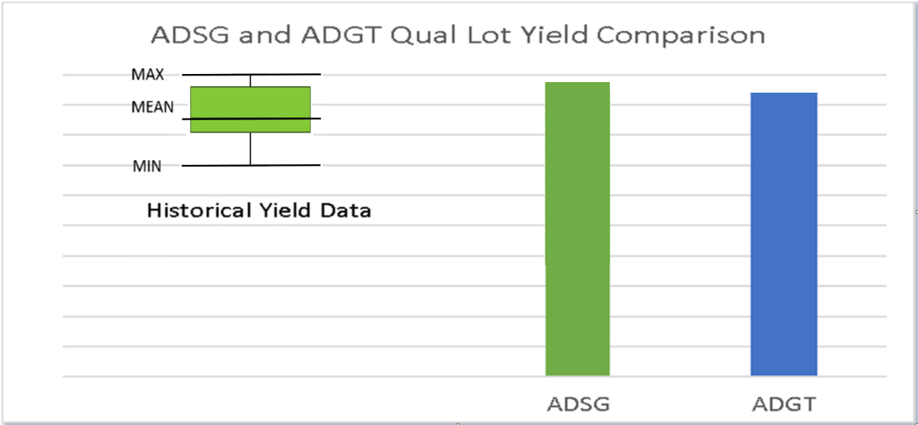

To ensure QA Program does not trim untrimmed/fresh parts, samples of untrimmed or fresh parts were tested using QA Program. LT8609 has no trimming on final test, criteria not applicable

To gather test performance data to allow estimation of the overall test repeatability and reproducibility from the production test solution, GR&R was performed on 10 serialized units tested on 1 test board and 3 test systems.

To qualify LT8609S, LT8610 a 42V, 2.5A Synchronous Step-Down Regulator with 2.5µA Quiescent Current was identified as GR&R data representative based on the following criteria: same product technology, same functionality and operation, and same tester platform. Both LT8609S and LT8610 have the same typical application of Synchronous Step-down Regulator and have the same range of adjustable and synchronizable frequency. Both have the same test coverage on critical datasheet parameters: Minimum Input Voltage, Vin Quiescent Current, Vin Current in Regulation, Feedback Reference Voltage, Feedback Voltage Line Regulation, Feedback Pin Input Current, Minimum On/Off time, Oscillator Frequency, Top Power NMOS Current Limit, PG Upper/Lower Threshold Offset, PG Leakage and TR/SS Source Current. GR&R result was analyzed and summarized in Table 7.

**Table 7:** *GR&R Result*

|  |  |  |  |  |  |  |
| --- | --- | --- | --- | --- | --- | --- |
| **Generic** | **Package** | **Lot Number** | **No. of Units** | **No. of Test Boards** | **No. of Testers** | **All parameters passed R&R % =<10%?** |
| LT8610 | 16-LEAD PLASTIC MSOP | 1040986.2 | 10 | 1 | 3 | YES – ALL PASSED |

**APPROVALS:**

Technical Review Board No. [60579](http://wwmbe.analog.com/apps/mcm/projects/b5010606-3597-2a49-c640-39e8923e2093) - ADSG to ADGT Test Transfer

**Supporting Documents:**

FMEA - [PFMEA00236](http://wwmfg.analog.com/WWQuality/Apps/PFMEA/DrawForm.cfm?DocId=1597) PFMEA for Linear Test Pick and Place

Control Plan - [CP00107](http://wwmfg.analog.com/wwquality/apps/ControlPlan/DrawForm.cfm?DocId=143) Control Plan for LT Pick and Place

**ADDITIONAL INFORMATION:**

Homepage: <https://www.analog.com/en/index.html>

Customer Service: <https://www.analog.com/en/support/technical-support.html>